Mrs. Housman’s 3rd Grade

Classroom Handbook

2011-2012

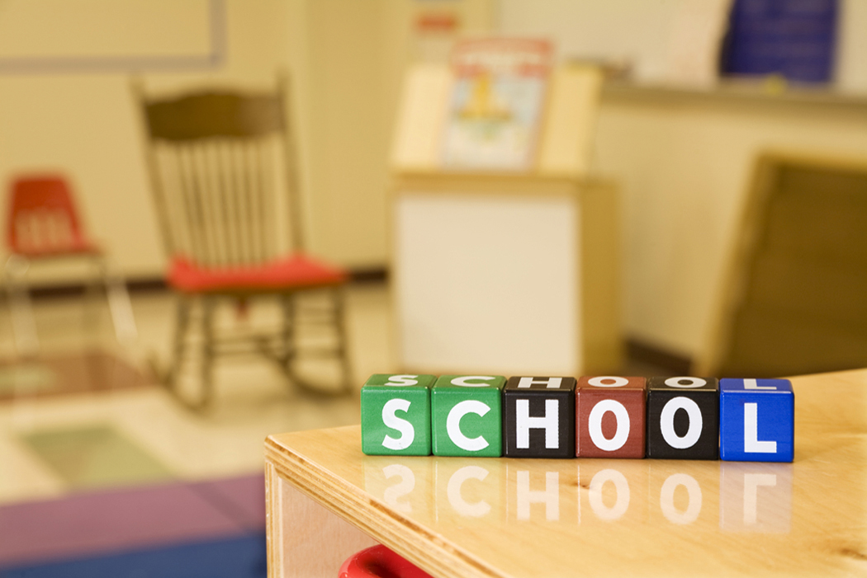

Hodgeman County Elementary School

620-357-8395

Mrs. Julie Housman

[jhousman@usd227.org](mailto:jhousman@usd227.org)

Hello Third Grade parents,

I want you all to know how excited I am for this opportunity to be your child’s classroom teacher. I am ready to dive into academics and help your child reach their full academic potential this year while exposing knowledge and interests they didn’t even know existed. I take this task very seriously and want to do what is right for each and every student in my classroom.

Confucius, a famous philosopher, once said, “Choose a job you’ll love, and you’ll never have to work a day of your life.” I believe this statement fully and am thankful I have found this ‘job’. On the days where it truly feels like work (yes, those happen no matter what you do), I always challenge myself to look back because there is NOWHERE else I’d rather be. The classroom is where I belong. I am running my classroom off the idea that there is a time for work and a time for play, and sometimes, when we are lucky, work can seem like play. To sum it up: when learning feels like work for the students, my job feels like work; when learning feels fun for the students, my job becomes fun.

I know as the year goes by we will all grow accustomed to each other and how each of us operates. It will take time but I know it will be great. If you would please read through this handbook, I know you can get an understanding of my classroom and the school policies and help avoid common problems or misunderstandings. You are always welcome to contact me at school, through e-mail, or a note in your child’s folder. I know that I will be hanging around before and after school as well, so please stop by if you have any concerns or questions.

School Phone: 620-357-8395 E-mail: [jhousman@jetmorek12.org](mailto:jhousman@jetmorek12.org)

I know this will be a fantastic year; with another year under my belt (and enough coffee) all things are possible! I am looking forward to the year!

Sincerely,

Our Class 2011-2012

**Sorry, I am not able to post student’s names online!**

I expect everyone to learn to appreciate all classmates and be kind in all situations. This is very important to me. I believe each and every student on this list has unique qualities to bring to this class that are to be embraced. As my mom would say, “If everyone was like you, what fun would the world be?!” She is a very smart woman! ☺

|  |  |  |  |  |  |
| --- | --- | --- | --- | --- | --- |
|  | Monday | Tuesday | Wednesday | Thursday | Friday |
| 8:00- | Morning Routine & Bell Work | Morning Routine & Bell Work | Morning Routine & Bell Work | Morning Routine & Bell Work | Morning Routine & Bell Work |
| 8:10- 8:40 | Math | Math | Math | Math | Math |
| 8:40-9:05- | **Music** | **Music** | **Music** | **Music** | **Music** |
| 9:10- 9:35- | **Physical Education** | **Physical Education** | **Physical Education** | **Physical Education** | **Physical Education** |
| 9:35-9:40 | Restroom & Drinks | Restroom & Drinks | Restroom & Drinks | Restroom & Drinks | Restroom & Drinks |
| 9:40-10:10 | SSR or continue Math  (Title I) | SSR or  Continue Math  (Title I) | SSR or  Continue Math  (Title I) | SSR or  Continue Math  (Title I) | SSR or  Continue Math  (Title I) |
| 10:10- 11:15 | Reading  Spelling | Reading  Spelling | Reading  Spelling | Reading  Spelling | Reading  Spelling |
| 11:25- 11:45 | **Lunch** | **Lunch** | **Lunch** | **Lunch** | **Lunch** |
| 11:50 12:10 | **Recess** | **Recess** | **Recess** | **Recess** | **Recess** |
| 12:10- 12:15 | Restroom & Drinks | Restroom & Drinks | Restroom & Drinks | Restroom & Drinks | Restroom & Drinks |
| 12:15-12:30 | Teacher Read Aloud | Teacher Read Aloud | Teacher Read Aloud | Teacher Read Aloud | Teacher Read Aloud |
| 12:30 12:40 | Work on Homework | Work on Homework | Work on Homework | Work on Homework | Work on Homework |
| 12:40-1:15 | **Seminar**  Small group meetings **\*Centers\*** | **Seminar**  Small group meetings | **Seminar**  Small group meetings  **\*Centers\*** | **Seminar**  Small group meetings | **Seminar**  Small group meetings  **\*Centers\*** |
| 1:15- 2:00 | English | English | English | English | English  **1:30-1:45**  **3H Checkout** |
| 2:00 2:20 | **Recess** | **Recess**  2:00-2:05  **Art**  **2:05-2:45** | **Recess** | **Recess** | **Recess** |
| 2:20- 2:50 | Social Studies/  Science | Social Studies/  Science | **2:30-3:00**  **Library Skills** | Social Studies/  Science |
| 2:50- 3:00 | Wrap up & Review | Wrap up & Review | Wrap up & Review | Wrap up & Review |
| 3:00- 3:30 | **Computer** | **Computer** | **Computer** | **Computer** | **Computer** |
| 3:30-3:40 | End of the Day Routine | End of the Day Routine | End of the Day Routine | End of the Day Routine | End of the Day Routine |

3H Class Schedule

*I will spend the first few weeks getting familiar with this particular group of 3rd graders and what works for them, myself, and the curriculum goals. I will learn their limitations and what makes the day flow best for everyone. This schedule is not fixed in stone but is more of an outline of what I hope to accomplish in the school day. Classroom Management Plan

I have developed a classroom management plan to be in olace at all times. My goal as a teacher is to help your student reach their highest potential as a student and as a growing individual as well. I expect students to take responsibility for their actions or inactions and excuses are not acceptable. I want students to understand they are in full control of themselves and will be held accountable for all of their actions, both good and not so good. They are in control of their behavior, no one else.

My last employer told future parents, “She’s a lot of fun, but she’s tough, she doesn’t fool around.” I find this to be true when it comes to classroom management. The classroom is a place for all to learn and grow and my classroom management plan is to help create this kind of atmosphere. This year I will be using the classroom management plan “Be a Top Apple”. In previous years, I used an at home management plan that was to be returned every day. I am going to see how it goes without it this year, but I wouldn’t be surprised if it pops up again. If it does, I’ll be sure to explain it in a parent letter. As far as this new classroom management plan, I’ll try to go into great detail because in the past, a parent thought that the ‘yuck’ pot, a portion of my pervious classroom management plan, was a literal cooking pot that the student would have to stand in. This was NOT the case, but it did give me a good laugh and memory!

 Be at Top Apple! 

The classroom management plan I am using this year is called “Be a Top Apple”. A classroom management plan is a system in place to let the students know where they stand as far as classroom behavior is concerned. It consists of three different colored apples that will be hanging in my classroom: Green, Yellow, and Red. The green apple represents superior behavior of the student for something extraordinary to show their growth, kindness, or effort in academics or personal actions. A yellow apple represents that the student made a choice that is not approved of and goes against the classroom rules. A red apple represents a behavior that is not acceptable and the parents will be notified of the actions. I see no need for anyone to act inappropriately when the rules and expectations are clearly set. I genuinely believe that I will not have any problems. I base my classroom off of respect for my students as individuals and in return I receive their respect.

There are three basic rules in my classroom and rule cards that correspond with each rule hangs near the apples to remind us all of what will help them become a top apple. The rules and rule cards are: *1. A golden ruler card: Treat others the way you want to be treated at all times. 2. A zipper card: No talking while the teacher or others are talking and be a good listener. 3. Bubble card: Keep your body in your bubble/ hands, feet, and all other objects to yourself.* All names of the students are listed on a worm; if the child chooses to behave in a manner that is not acceptable, I will place a physical reminder of a rule card with the rule that is not being followed on their desk. If the behavior is not corrected they are responsible for taking their worm and place it into the yellow or red apple (depending on actions) when instructed. Once their name is in the yellow or red apple space they are required to do two things: 1.) spend 10 minutes of their recess walking or standing with Mrs. Housman. 2.) Once they have been dealt their consequence, they must tell me what they have done wrong, how they plan to fix it, and what they believe will happen if I have to remind them of how to behave. Once I feel the two steps have been sincerely completed, the student will be instructed to take their name from the yellow or red apple spaces and rejoin the rest of their class worms. The green apple will represent a child doing an unexpected positive behavior. The child will earn the child a special reward for that day and recognition & probably a note home to inform you of their positive behavior.

I have taught many age levels in vastly different places: Kindergarten to high school Biology in Kansas to the 6th Grade in New York. During teaching all levels and locations, I have learned that people are generally the same: they all want respect and to be understood. I give students the respect and admiration they deserve and in turn I have always been given respect. I plan on this staying true and don’t foresee anything but a great year for this class. Please let me know if this is unclear and would like to discuss it with me.

Grading Scale

The grading scale for the 3rd grade will consist of the letter grade scale that is shown below. Also, the letters E,S, and N will be used. These letters stand for Excellent, Satisfactory, and Needs Improvement.

100% A+

99%-94% A

93-90% A-

89%-87% B+

86%-84% B

83%-80% B-

79%-77% C+

76%-74% C

73%-70% C-

69%-67% D+

66%-64% D

63%-60% D-

59% and below is Failing

If you have any questions, please let me know.

Thank you!

Mrs. Housman **Communication Folder/Take Home Folder**

The bottom line is that this folder is *important!*  Your child will be bringing this home every day and it is to be **returned every day.** I am very straight forward about this; it is a major responsibility and a source of primary communication for the student, parents, and teacher.

Please check your child’s schoolbag daily for this folder. Remove the papers and read through them daily, not once a week, or it will outgrow the folder and make a mess for all of us, therefore making it hard for your 3rd grader to be organized. It will contain notes from school, notes from myself, completed work (for the refrigerator of course….), and HOMEWORK to be completed.

I will check the folders every morning for: 1.) notes from you 2.) work that was to be completed at home. This folder is a great line of communication, keeping everyone ‘in the loop’. If it is not returned, they will be spending five minutes of recess with Mrs. Housman walking.

My experience with this kind of folder/mode of communication is very positive. It is the perfect way for your students to have responsibility AND to be held accountable for their actions. I value these folders and appreciate your help with making this form of communication work for all of us!

CHECK & READ BOTH SIDES OF THE FOLDER DAILY…..

AND RETURN IT TO SCHOOL!!!!

**\*MATH\***

Each day your child will participate in a wide variety of mathematics activities. Your child will learn through hands-on experiences, discussion, and exploration.

Our math day begins with math meeting. This is a time when we participate in a wide variety of every day skills. A ‘Student of the Day’ assists in asking questions about the calendar, time, temperature, patterns, classroom graphs, money, and high order thinking skills.

Another part of third grade math is the lesson. During the lesson a new concept is presented through discussion and activity. Concepts and skills in third grade include computation, problem solving strategies, measurement, geometry, money, time, identifying patterns, fractions, graphs, and charts.

Number facts are introduced using fact strategies and are practiced throughout the year. The children compete only against themselves and strive to improve their own scores on fact sheets. Children are encouraged to practice the number facts at home through games and activities as well.

After each lesson we will practice the new learning, as well as concepts previously introduced, through guided written practice. The children complete and correct side A of a practice sheet in class. Side B is your child’s homework. The examples are similar to those on side A. However, I will allow your child to do the homework side B of the practices sheet in school if time permits and they have all other assignments completed or corrected.

Your child will have math homework most nights a week, especially as the school year picks up. If your child has homework, please assist the child by reading the problems on side B, if necessary. Allow your child to arrive at the answers independently. Check your child’s work and help your child correct mistakes. If you helped your child with an example, please write a short comment by the problem number to let me know that this was a difficult question.

**\*\*\*It is important that your child return the homework the next day.\*\*\***

Assessment of your child’s progress will occur every five lessons. Each written assessment includes skills your child has been practicing throughout the year. We will strive for 80% mastery on all assessments. Any missed objectives will be reviewed and re-taught. During our conferences, I will share my observations about your student’s progress. Please contact me if you have any questions about the math program or your child’s progress.

-Mrs.Housman

Class Parties!!! ☺

C:\Program Files\Microsoft Office\MEDIA\CAGCAT10\j0305493.wmf C:\Program Files\Microsoft Office\MEDIA\CAGCAT10\j0183290.wmf C:\Documents and Settings\User\Local Settings\Temporary Internet Files\Content.IE5\IR87V94A\MC900304919[1].wmf C:\Program Files\Microsoft Office\MEDIA\CAGCAT10\j0304933.wmf

Volunteer room mothers/fathers will host our holiday parties. A sign up sheet will be available in the third grade classroom during our **open house**.

C:\Documents and Settings\User\Local Settings\Temporary Internet Files\Content.IE5\H023XEQ1\MC900413580[1].wmf

I welcome birthday celebrations if this is what you choose; I am a VERY big fan of birthdays! ☺ I do lots of special things throughout the day to celebrate that student. I do ask if you send or bring treats that they all be the same. Please let me know a day or so in advance if you plan on sending or bringing treats so that I can allow time toward the end of our school day to CELEBRATE!

Personal birthday invitations may be sent to school for delivery, but only if all boys, all girls, or the whole third grade class will receive one.

Accelerated Reading

The third grade class will be participating in accelerated reading this year! It is commonly referred to as AR. It is ‘the norm’ in most of our elementary school classrooms and is going to be implemented this year in 3rd grade. The purpose of AR is to help students read for comprehension.

Each child is given a goal based on their personal reading level and teacher observation. After they have their goal for the nine week period, they will begin reading books and taking comprehension tests to receive points for those books. Each book has a point value. If the child passes the comprehension test with 100%, missing no questions, they receive full points for that particular book. The point value will decrease if the student misses a comprehension question. Please contact me with any questions or ask your 3rd grader, we will go over the process in great detail. We will also go over how to read the T.O.P.S. reports over the books that will be sent home for you to view. A T.O.P.S. report is kind of like a grade for the test. For the first few tests, I will highlight the important areas on the T.O.P.S. reports so we can all get the hang of AR.

Reading at home and school will help your student reach their goal. I will be having a celebration at end of the 9 weeks to celebrate the students who have met their reading goals. …Make sure to keep them reading, they won’t want to miss out on these celebrations. They will be AWESOME! ☺

Recess

C:\Documents and Settings\User\Local Settings\Temporary Internet Files\Content.IE5\H023XEQ1\MC900113404[1].wmfI know it is still feeling like summer, but when the fall weather comes around, I need your child to be dressed appropriately for recess. I want the class to be outside when weather permits and enjoy the fresh air! However, if I believe it is cold and your child doesn’t have a coat, they will be sitting in the classroom or office during recess. It is my job to take care of them while they are at school and away from you; I am kind of a stickler for this. If it MIGHT get cool, make sure your child has a coat! I want them to be happy and healthy!

Please sign and return this page to Mrs. Housman by September 1st. Thank you! ☺

I have read and understand all policies that are covered in this handbook.

Parent:______________________ Date:_________

Student:_____________________ Date:_________